Unit 2 Performance Task B
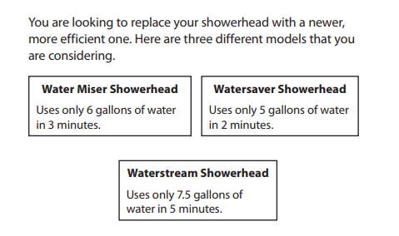
“Showerhead Dilemma”

We are going to compare the amount of water each showerhead uses. Would you want a showerhead that uses the most water or the least water??
1.) Complete a table to show how much water each showerhead uses.
a.) Water Miser
b.) Watersaver
c.) Waterstream

2.) Find the amount of water each showerhead uses in 1 minute.
a.) Water Miser uses __________ gallons in one minute.
b.) Watersaver uses ________ gallons in one minute.
c.) Waterstream uses _______ gallons in one minute.
2.) For each showerhead write an equation to represent the amount of water used(y) by each showerhead based on the minutes(x). The first one is done for you.
Remember: y = mx + b
a.) Water Miser: y = 2x (2 gallons per minute)
b.) Watersaver:
c.) Waterstream:
3.) Using the equations above, find the amount of water used after 6 minutes and 10 minutes.
a.) Water Miser: 6 Minutes 10 Minutes
y = 2x y = 2x
y = 2(6) y = 2(10)
y = 12 y = 20
So, Water Miser used 12 gallons of water in 6 minutes and 20 gallons in 10 minutes.
b.) Watersaver: 6 Minutes 10 Minutes

c.) Waterstream: 6 Minutes 10 Minutes

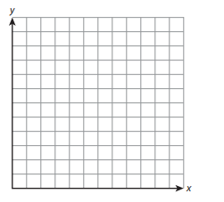
4.) Pick one of the showerheads and graph the relationship using the table from #1.

5.) Which showerhead would you buy? Why? Do we want a showerhead that uses the least water or the most water?
________________________________________________________________________________________________________________________________________________________________________________________________________________________________________________________________________________________________________________________________________________________________________________________________________________________________________________________________________________________________________________________________________________________________________________________________________________________________________________

