Name:____________________ Class:____________
Date:____________ Grade 8 Math
Unit 2 Performance Task B
“Showerhead Dilemma” Rubric 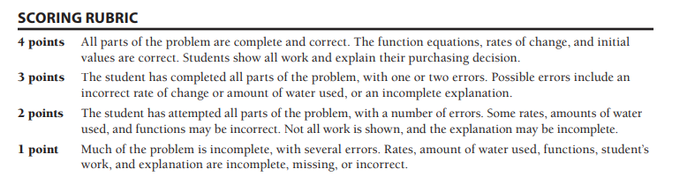
Grade:______________________
Comments:

Name:____________________ Class:____________
Date:____________ Grade 8 Math
Unit 2 Performance Task B
“Showerhead Dilemma” Rubric
Grade:______________________
Comments:

